## **Chapter 4: Electronic Cabling and Testing**

### 4.1 Introdution

The success of any autonomous system not only depends on the quality of its hardware and software but also on the precision and reliability of its electrical integration. In the Ocean Cleaner project, electronic cabling forms the backbone of communication and power distribution across all critical components, from sensors and actuators to processing units and power systems.

This chapter focuses on the careful planning and execution of the electronic cabling layout, ensuring that all modules are correctly connected and securely fastened to withstand harsh marine conditions. It also highlights the safety protocols applied to prevent short circuits, interference, and overheating. Additionally, the chapter describes the communication protocols used, such as UART, which ensure reliable data exchange between the Raspberry Pi, Arduino, sensors, and actuators. These protocols were selected based on their suitability for real-time, low-latency communication in embedded marine applications.

In addition, rigorous testing of both the hardware and software was conducted to validate the system’s performance and reliability. This includes unit testing for individual components, integration testing to evaluate how different modules interact, and system-level testing in simulated and real-world environments to ensure the Ocean Cleaner performs its mission of autonomous waste collection effectively and safely.

### 4.2 Electronic Cabling

This section outlines the wiring configuration for key components, ensuring robust connectivity and validated data transmission across the system.

### Raspberry Pi 4 and IMU

The Raspberry Pi 4 was connected to the 9-axis IMU using the I2C protocol, with SDA on Pin 3 and SCL on Pin 5, enabling seamless orientation data transfer critical for the Ocean Cleaner’s navigation in marine environments. I2C was activated through raspi-config, and the connection was verified using `i2cdetect`` command to ensure reliable communication. This setup, as shown in Figure 4.1, forms a robust foundation for real-time motion tracking and stability control.

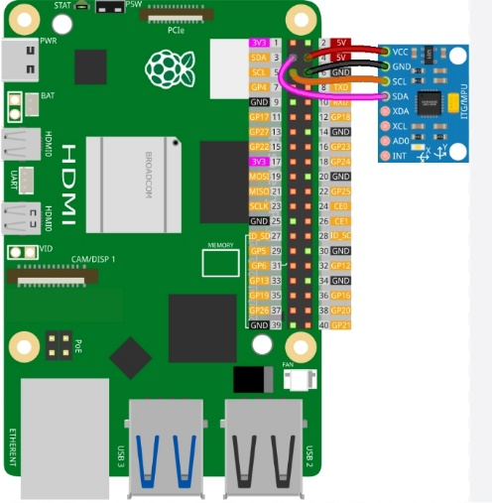

*Figure 4.1: Raspberry Pi 4 and IMU wiring.*

### Raspberry Pi 4, Arduino Uno and SIM808 Module

To enable UART communication, the Raspberry Pi 4’s serial port was activated and the serial console (shell) was disabled via raspi-config to prevent conflicts, ensuring seamless data transfer. A Python script utilizing the pyserial library was employed to verify UART communication with the Arduino Uno and SIM808 module, specifically targeting the /dev/ttyAMA0 port to confirm reliable data transmission. The SIM808 was connected to the Arduino Uno via UART on pins 7 and 8 for GPS and communication functions, while the Arduino Uno was linked to the Raspberry Pi 4 through UART (Arduino pins 0 and 1 to Pi 4 pins 8 and 10) with shared GND lines between the Pi 4, Arduino, and SIM808 for stable signal integrity. The Arduino draws 5V power from the Pi 4, which is powered via USB Type-C from a power bank, and the SIM808 is independently powered by the same power bank, as depicted in Figure 4.2, enabling robust navigation and remote monitoring for the Ocean Cleaner.

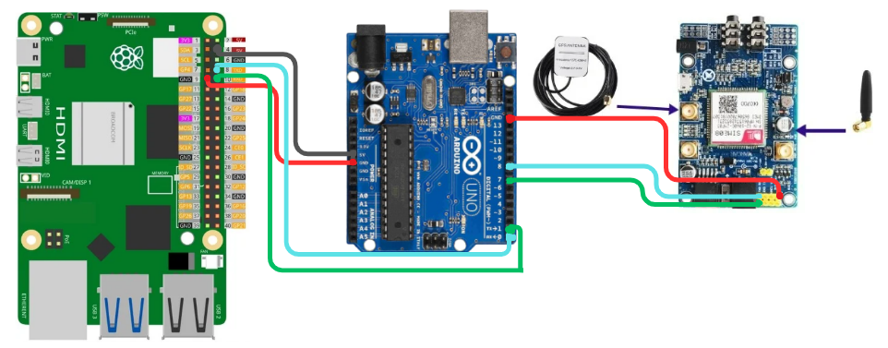Figure 4.2: Raspberry Pi 4, Arduino, and SIM808 wiring.

### Raspberry Pi 4 and Rplidar A1

The RPLIDAR A1 was connected to the Raspberry Pi 4 via a single USB cable, which handles both power delivery and data transmission, streamlining integration for real-time environmental mapping and obstacle detection in the Ocean Cleaner’s navigation system. To configure the Raspberry Pi 4, the USB port was identified using ls -la /dev | grep ttyUSB to locate the RPLIDAR’s device (typically /dev/ttyUSB0), and permissions were set with chmod 666 /dev/ttyUSB0 to ensure accessible communication without root privileges. This setup, as shown in Figure 4.3, enables efficient 360° point cloud generation for autonomous operation in marine environments.

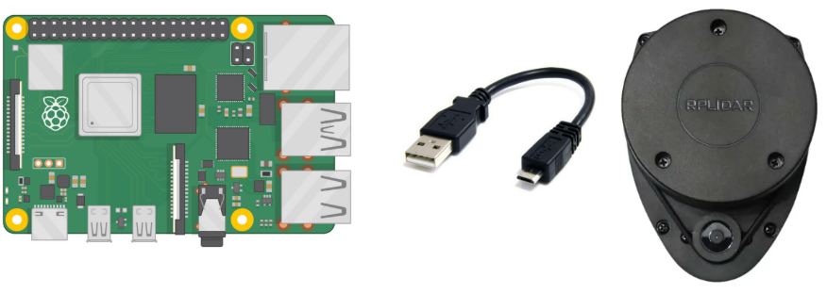

*Figure 4.3: RPLIDAR A1 and Raspberry Pi 4 USB wiring.*

### Raspberry Pi 4 Camera Integration

The Raspberry Pi Camera (8MP, 60° FoV) was connected to the Raspberry Pi 4 via the CSI port, enabling high-resolution image capture for waste detection in the Ocean Cleaner project. Due to compatibility issues with the libcamera library on Ubuntu 20.04, the ffmpeg library was used to configure and access the camera, streaming 640x640 images for the AI model, ensuring reliable waste identification.

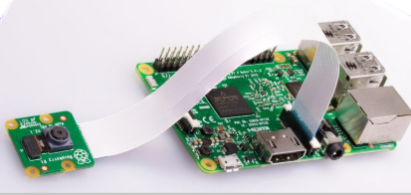

*Figure 4.4: Hardware wiring of Raspberry Pi Camera to Raspberry Pi 4 CSI port.*

### Motor Control Integration

The motor control system for the Ocean Cleaner utilized two brushless triphase motors, each connected to an Electronic Speed Controller (ESC), with the ESCs wired to Arduino Uno pins 9 and 10 for PWM control and shared GND for stable operation. The ESCs were powered by separate LiPo batteries (Zeee 4S 14.8V 5200mAh) to meet the high current demands of the APISQUEEN U2 MINI thrusters, while the Arduino Uno was powered via the Raspberry Pi 4’s 5V output, connected through UART (Arduino pins 0 and 1 to Pi 4 pins 8 and 10) with a shared GND, reusing the same power and communication setup as the SIM808. This hardware wiring configuration, depicted in Figure 4.5, integrates the Raspberry Pi 4, Arduino, two ESCs, two motors, and dual LiPo power supplies, ensuring precise differential steering for navigation in marine environments.

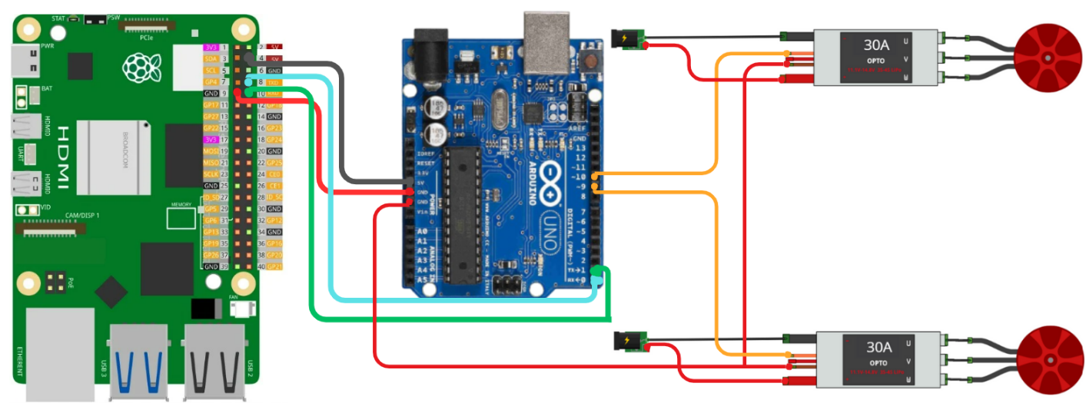

*Figure 4.5: Hardware wiring of Raspberry Pi 4, Arduino, two ESCs, two motors, and LiPo power supplies.*

### Power System Integration

The power system for the Ocean Cleaner was wired to ensure reliable operation, with all components except the motor cables housed in a protective box to prevent water exposure. The Raspberry Pi 4 and SIM808 module were powered via a TECTIN 20000mAh 66W power bank, connected through a USB to Type-C cable for the Pi 4 and a USB to DC cable for the SIM808, with cables secured inside the box. The two APISQUEEN U2 MINI thrusters, each paired with an ESC, were powered by separate Zeee 4S 14.8V 5200mAh LiPo batteries, with positive and negative terminals wired to the ESCs, while only the motor cables extended outside, designed to withstand water contact. This setup ensures stable power distribution, minimizes overheating risks, and supports extended mission durations for autonomous waste collection.